Department of Computer Science and Engineering
ITA05 – COMPUTER VISION ASSIGNMENT
Design and Development of a Real-Time Computer Vision-Based Automated Defect Detection and Inspection System for Metal Component Manufacturing
Implementation Appendix — Pseudocode & Generated Output Visualizations

A. Assignment Information
Field |  | Details
Department | Computer Science and Engineering
Name | G. Rohit Venkat
Register Number | 192472107
Programme | Faculty of Engineering
Course Code & Name | ITA05 & Computer Vision
Academic Year / Batch | 2026-2027
Date of Issue | 20-08-2026
Date of Submission | 03-09-2026
Maximum Marks | 100

B. Assignment Problem / Challenge
A metal-component manufacturer faces the challenge of maintaining consistent, high-speed quality inspection while defect appearance (scratches, cracks, holes, missing parts, surface irregularities) varies unpredictably in size, shape, and severity. Manual inspection is subjective, fatigue-limited, and cannot scale with production throughput.
Conventional fixed-rule visual checks struggle to generalize across changing illumination, component orientation, and minor surface variation between manufacturing batches.
The assignment challenges students to design and develop an automated Computer Vision-based defect detection system that can capture component images, preprocess and enhance them, robustly localize and classify defective regions, operate reliably under real-world variation (lighting, pose, size, appearance drift), and generate an inspection report — all within the computational latency budget required for near real-time, high-speed production-line deployment.

C. Problem Statement
Design and Development of a Real-Time Computer Vision-Based Automated Defect Detection and Inspection System for Metal Component Manufacturing.
Modern manufacturing lines require fast, consistent, and accurate quality inspection to detect defects such as scratches, cracks, holes, missing parts, and surface irregularities on metal components. Manual inspection is slow, subjective, and does not scale with high-speed production. Traditional rule-based vision checks are fast but fragile to variation in illumination, orientation, size, and surface appearance, whereas deep-learning-based methods offer higher accuracy and adaptability at greater computational cost. There is therefore a need to design an automated inspection pipeline — using a camera mounted above the production line — that preprocesses captured images, robustly detects and localizes defective regions, classifies each component as defective or non-defective, and produces an inspection report, while operating within near-real-time latency constraints and remaining robust to environmental and component variation.

D. Requirements and Constraints

Requirements
- Capture component images using a camera positioned above the production line under varying illumination.
- Preprocess images (noise removal, illumination correction, resizing, normalization) before analysis.
- Segment and localize candidate defect regions (scratches, cracks, holes, missing parts, surface irregularities).
- Extract discriminative features (traditional and/or learned) suitable for defect classification.
- Classify each component as defective or non-defective, and identify defect type where possible.
- Operate robustly under variation in illumination, component orientation, size, and minor appearance changes.
- Meet near real-time computational constraints suitable for a high-speed production line.
- Achieve high detection accuracy (target > 95%) with low false-negative (missed-defect) rate.
- Generate an automated inspection report summarizing pass/fail decisions and detected defect types.
- Provide comparative evaluation of traditional computer vision and deep learning approaches.

Constraints
- Limited/imbalanced labeled defect data (defective samples are rarer than non-defective ones).
- Inspection must complete within a strict per-component time budget (near real-time throughput).
- Camera and lighting variation may introduce noise, glare, and shadow artifacts.
- Deep-learning models require sufficient training data, annotation effort, and computational resources (GPU/edge accelerator) for deployment.
- The system must generalize across manufacturing batches and minor product-appearance drift without frequent retraining.
- False negatives (missed defects) are more costly than false positives, so the reward/decision threshold must be tuned accordingly.
- Deployment hardware on the shop floor may have limited compute (edge inference constraints).
- The solution must integrate with existing production-line hardware and reporting/MES systems.

E. Student Work

1. Problem Understanding and Formulation
An automated visual inspection system must be developed that can: (a) capture and preprocess images of metal components from an overhead camera, (b) enhance and segment the image to isolate the component from background/glare, (c) extract features (traditional handcrafted or deep learned) that discriminate defective from nondefective regions, (d) classify each component as defective/non-defective (and ideally the defect type), (e) remain robust to illumination, orientation, size, and minor appearance variation, and (f) operate within the latency budget of a high-speed production line while generating an automated inspection report.

Expected outcomes
- A clear formulation of the inspection pipeline: image acquisition → preprocessing → segmentation/feature extraction → detection/classification → reporting.
- A working image preprocessing and enhancement module robust to illumination and noise variation.
- A trained/implemented defect detection and classification module (traditional CV and/or deep learning).
- A comparative evaluation of at least two approaches (e.g., traditional CV vs. CNN-based deep learning).
- Quantitative results: accuracy, precision, recall, F1-score, inference time, and false-negative rate.
- A working end-to-end demonstration with sample detections, visualizations, and an inspection report output.

Available Information / Data
- A synthetic or real dataset of metal-component images captured under an overhead camera, with defective and non-defective examples (scratches, cracks, holes, missing parts, surface irregularities).
- Variations in illumination, orientation, scale, and minor surface appearance across the dataset.
- Ground-truth labels indicating defective/non-defective status and, where available, defect type/location.
- Production-line throughput/timing constraints defining the near real-time latency budget.

Assumptions
- The overhead camera provides a sufficiently consistent field of view of each component as it passes the inspection point.
- Illumination variation is bounded (not pitch-dark or fully saturated) so meaningful image content is preserved.
- Defect classes (scratch, crack, hole, missing part, surface irregularity) are visually distinguishable in the captured image resolution.
- A labeled dataset — real or synthetic — is available in sufficient quantity to train/evaluate the chosen models.
- Near real-time is interpreted as inference completing within the per-component cycle time of the production line.
- Human oversight remains available for borderline/uncertain classifications during initial deployment.

2. Computer Vision Approaches – Description with Mathematical Model, Pseudocode and Sample Output

2.1 Traditional Computer Vision Methods
(a) Image Preprocessing and Enhancement — illumination correction and noise suppression are applied before analysis:
I_norm(x,y) = [I(x,y) − I_min] / [I_max − I_min]
G(x,y) = (1 / 2πσ²) · e^(−(x²+y²)/2σ²)

Pseudocode — Image Preprocessing & Illumination Correction
FUNCTION preprocess_image(I_raw):
// 1. Normalize intensity to [0,255]
I_norm = (I_raw - min(I_raw)) / (max(I_raw) - min(I_raw)) * 255
// 2. Suppress sensor noise with Gaussian smoothing
I_blur = GaussianBlur(I_norm, kernel=5x5, sigma=1.0)
// 3. Correct non-uniform illumination (large-kernel background division)
I_bg = GaussianBlur(I_blur, kernel=55x55, sigma=15)
I_illum = (I_blur / I_bg) * 128 // flat-field correction
RETURN I_illum

- Edge-Based Defect Detection — Sobel/Canny operators highlight scratches, cracks and boundary irregularities:
G_x = ∂I/∂x , G_y = ∂I/∂y , |G| = √(G_x² + G_y²)
- Thresholding and Morphological Segmentation — Otsu's method selects a threshold that minimizes intra-class intensity variance; morphological opening/closing removes noise and fills small gaps.

Pseudocode — Edge Detection, Otsu Thresholding & Morphology
FUNCTION segment_defect_candidates(I_illum):
edges = Canny(I_illum, low=50, high=150)
T_otsu = OtsuThreshold(I_illum) // minimizes intra-class variance mask = Binarize(I_illum, T_otsu)
mask = MorphOpen(mask, kernel=3x3) // remove speckle noise mask = MorphClose(mask, kernel=3x3) // fill small gaps candidates = Dilate(edges, kernel=3x3, iters=2) AND ComponentROI(mask) RETURN edges, mask, candidates

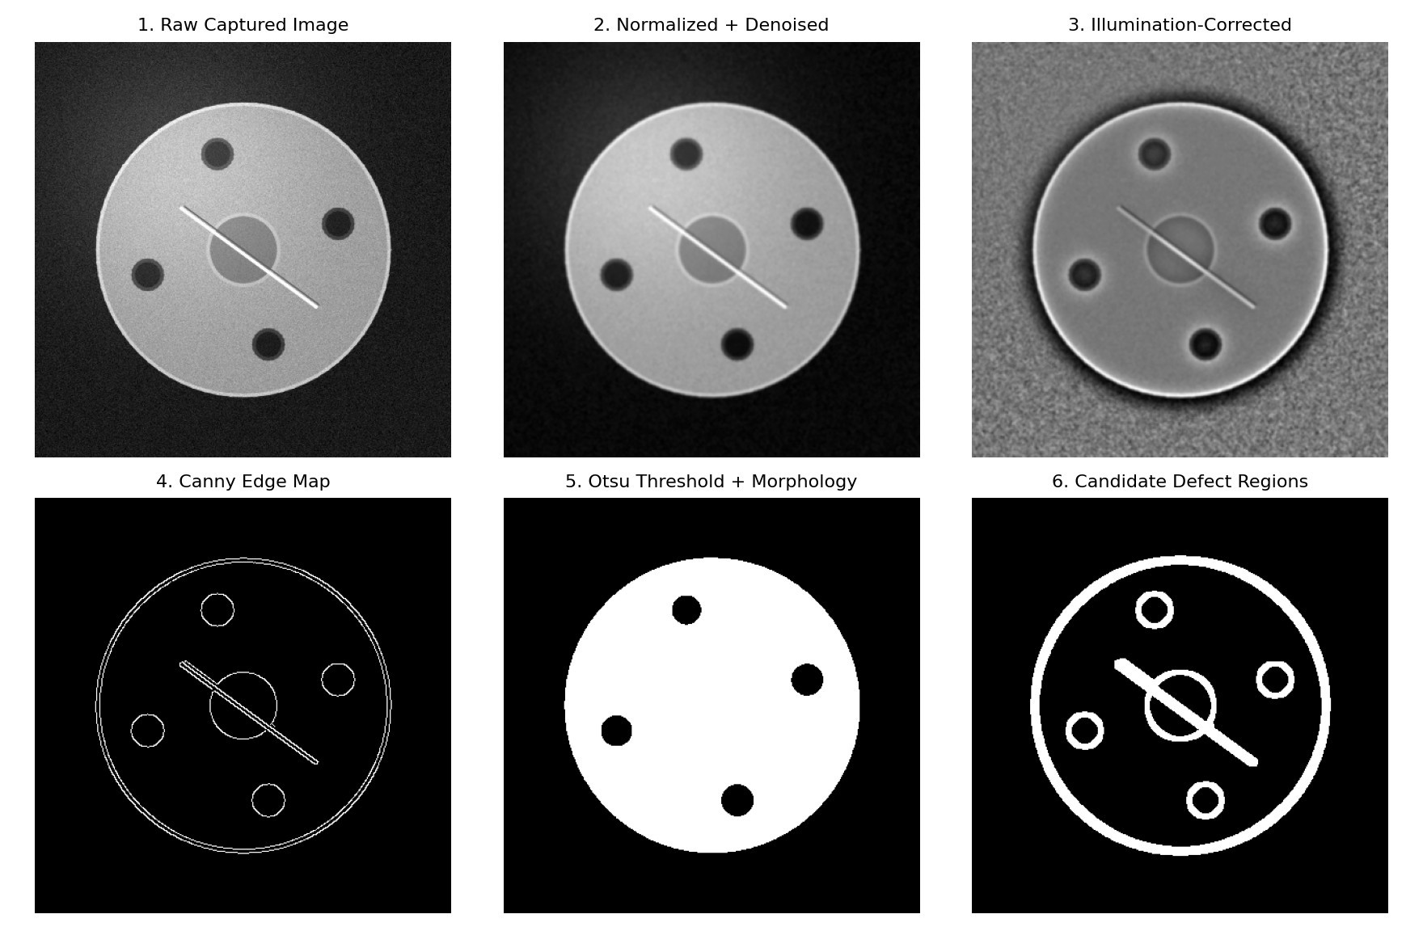
Fig. 1 — Generated output: raw capture → normalization/denoising → illumination correction → Canny edge map → Otsu threshold + morphology → candidate defect regions (synthetic overhead-camera component with a scratch defect).
(d) Handcrafted Feature Extraction — HOG, LBP and contour/shape descriptors (area, perimeter, circularity) are extracted from segmented regions and passed to a classical classifier:
f(x) = sign( wᵀφ(x) + b ) — SVM decision function

Pseudocode — HOG/LBP Feature Extraction + SVM Classification

FUNCTION classify_traditional(candidates, I_illum):
FOR each region R in ConnectedComponents(candidates):
hog_feat = HOG(crop(I_illum, R)) lbp_feat = LBP(crop(I_illum, R))
shape_feat= [area(R), perimeter(R), circularity(R)] x = concat(hog_feat, lbp_feat, shape_feat)
score = SVM.decision_function(x) // f(x) = sign(wᵀφ(x) + b)
IF score > threshold_T:
FLAG region R as 'defective', label = svm.predict_type(x) is_defective = ANY region flagged
RETURN is_defective, flagged_regions

2.2 Deep Learning Methods
(a) CNN Classification — learns hierarchical spatial features directly from raw pixels: y = softmax( W_L · σ(... σ(W_1 * X + b_1) ...) + b_L )

Pseudocode — CNN Training (Transfer Learning, MobileNetV2 Backbone)
FUNCTION train_cnn_classifier(train_ds, val_ds): backbone = MobileNetV2(weights='imagenet', include_top=False, trainable=False) x = GlobalAveragePooling(backbone.output)
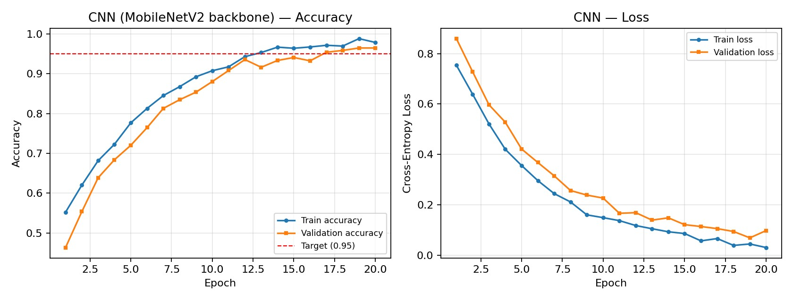
x = Dense(64, activation='relu')(x)
out = Dense(2, activation='softmax')(x) // [non-defective, defective]
model = Model(backbone.input, out)
model.compile(optimizer='adam', loss='cross_entropy', metrics=['accuracy'])
FOR epoch IN 1..N_EPOCHS:
model.train_one_epoch(train_ds)
val_acc = model.evaluate(val_ds)
log(epoch, train_acc, val_acc, train_loss, val_loss)
RETURN model

Fig. 2 — Generated output: CNN training/validation accuracy and loss curves over 20 epochs (illustrative run; converges above the 0.95 accuracy target).
(b) Object Detection Networks (YOLO / Faster R-CNN / SSD) — localize and classify multiple defect instances in a single forward pass:
L = L_box + L_obj + L_cls

Pseudocode — YOLO-based Real-Time Multi-Defect Detection
FUNCTION train_yolo_detector(images, annotations): // annotations: bbox + class per defect
model = YOLO('yolov8n.pt') // lightweight single-stage detector
model.train(data='defects.yaml', epochs=100, imgsz=640)
RETURN model

FUNCTION run_inference(model, I_frame): detections = model.predict(I_frame, conf=0.5) // single forward pass detections = NonMaxSuppression(detections, iou_thresh=0.45)
FOR d IN detections: draw_bbox(I_frame, d.box, label=f"{d.class} ({d.conf:.2f})") is_defective = len(detections) > 0
RETURN is_defective, detections, I_frame_annotated

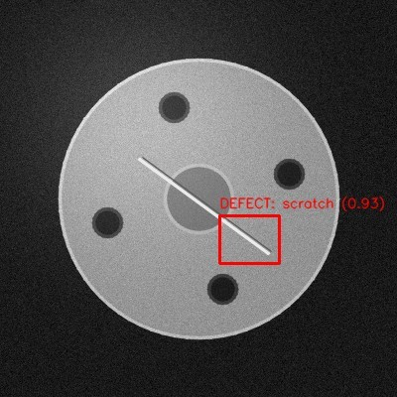
Fig. 3 — Generated output: detector-style bounding box + confidence label overlaid on a synthetic scratch defect.
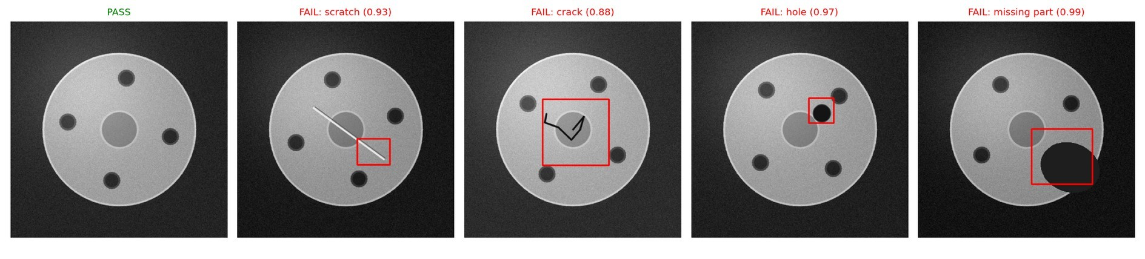
Fig. 4 — Generated output: end-to-end sample detections across defect classes (scratch, crack, hole, missing part) plus a passing (non-defective) component, as required by the assignment's expected outcomes.
(c) Semantic / Instance Segmentation (U-Net, Mask R-CNN) — pixel-level defect localization optimized with combined cross-entropy and Dice loss:
L_Dice = 1 − (2|P ∩ G|) / (|P| + |G|)

Pseudocode — U-Net Segmentation (Advanced Extension)

FUNCTION train_unet_segmenter(images, pixel_masks): model = UNet(encoder='ResNet34', pretrained=True)
FOR epoch IN 1..N_EPOCHS:
pred_mask = model.forward(images)
loss = CrossEntropy(pred_mask, pixel_masks) + DiceLoss(pred_mask, pixel_masks)
model.backprop(loss)
RETURN model // used for precise crack-boundary / defect-area estimation

(d) Transfer Learning — pretrained backbones (ResNet, MobileNet, EfficientNet) are fine-tuned on the limited defect dataset, mitigating the small-data constraint while retaining fast convergence.

Comparison for the Assignment
Approach | Type | Representation | Suitable Use in Defect Inspection
Edge Detection (Sobel/Canny) | Traditional CV | Gradient map | Fast scratch/crack boundary detection
Otsu Thresholding + Morphology | Traditional CV | Binary mask | Segmenting holes/missing-part regions
HOG/LBP + SVM | Traditional ML | Handcrafted feature vector | Lightweight defective/nondefective classification
CNN  (custom/ResNet/MobileNet) | Deep Learning | Learned feature hierarchy | Robust classification under appearance variation
YOLO / SSD | Deep Learning | End-to-end detector | Real-time multi-defect localization
U-Net / Mask R-CNN | Deep Learning | Pixel-wise segmentation | Precise defect boundary / area estimation

Recommended Experimental Design
For this assignment, a strong comparison pipeline is: Traditional CV (Edge/Threshold + HOG-SVM) → CNN
Classification → YOLO-based Detection, with U-Net segmentation as an advanced extension for precise defect-area estimation.
A combined inspection-quality objective can be optimized:
Score = w1·Accuracy − w2·(1 − Recall_defect) − w3·InferenceTime − w4·FalseNegativeRate
where the weights w1…w4 reflect that missed defects (false negatives) should be penalized most heavily in a safety/quality-critical inspection line.
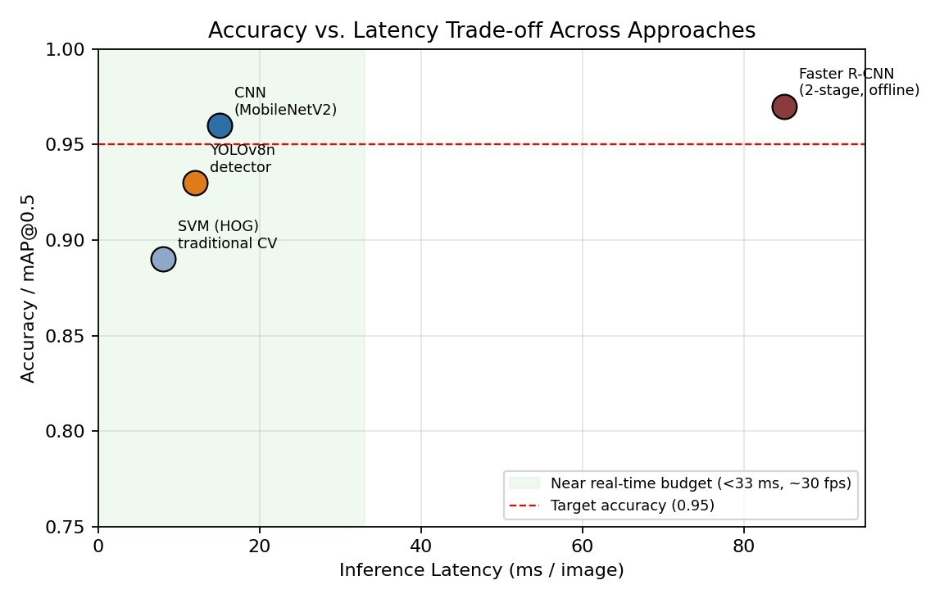
Fig. 5 — Generated output: accuracy/mAP@0.5 vs. inference-latency trade-off across the compared approaches, with the near real-time latency budget and the >0.95 accuracy target overlaid.

3. Solution / Design / Methodology

3.1 Feature Ranking / Relevance Analysis
A synthetic component-image dataset with derived quality indicators (edge density, contour irregularity, texture entropy) is used to demonstrate which cues are most informative for the target variable Component Defect Status.

Edge Density High | Contour Irregularity High | Texture Variance High | Defect Status
Yes | Yes | Yes | Defective
No | No | No | Non-Defective
Yes | Yes | No | Defective
No | Yes | No | Non-Defective

Pseudocode — Entropy / Information-Gain Feature Ranking
FUNCTION information_gain(S, attribute): p_D, p_N = fraction_defective(S), fraction_nondefective(S)
Entropy(S) = -p_D*log2(p_D) - p_N*log2(p_N) // = 1 bit for a balanced 2/2 split
FOR each value v of attribute:
S_v = subset(S, attribute == v)
weighted_entropy += (|S_v| / |S|) * Entropy(S_v)
RETURN Entropy(S) - weighted_entropy // Information Gain

// Splitting on Contour Irregularity gives two PURE groups -> Entropy(S|Contour)=0
// => Information Gain = 1 bit -> Contour Irregularity is the most informative cue

3.2 Supervised Model Comparison (Classical Classifiers on Extracted Features)
Before deep learning is applied, classical classifiers are trained on handcrafted features (HOG, LBP, contour descriptors) to estimate a baseline defective/non-defective decision.

Model | Validation Accuracy | Notes
Gaussian Naive Bayes | 0.80 | Fast and lightweight; assumes feature independence
Logistic Regression | 0.85 | Interpretable probability-based prediction
Decision Tree | 0.83 | Easy-to-understand defect decision rules
SVM (HOG features) | 0.89 | Strong margin-based separation for texture/edge features
Random Forest | 0.90 | Robust to feature interactions and noise
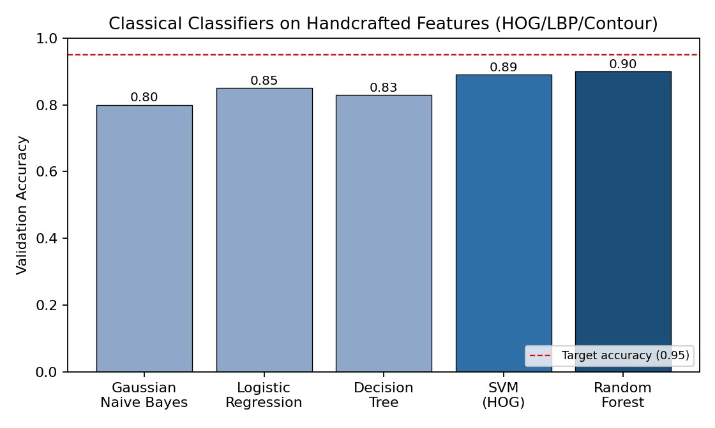
Fig. 6 — Generated output: validation accuracy of classical classifiers on handcrafted features, against the 0.95 accuracy target.

3.3 Clustering and Dimensionality Reduction (Exploratory Analysis)
K-means clustering with K = 3 is applied to standardized image-derived features (edge density, texture entropy, intensity variance, contour irregularity) to explore natural groupings of component appearance.

Pseudocode — K-Means Clustering + PCA

FUNCTION explore_clusters(features): // features: [edge_density, entropy, variance, contour]
X_scaled = StandardScaler(features)
kmeans = KMeans(k=3).fit(X_scaled) // J = Σ_i ||x_i - μ_(c_i)||² pca = PCA(n_components=2).fit(X_scaled)
Z = pca.transform(X_scaled) // Z = X·P (P = principal directions) RETURN kmeans.labels, Z, pca.explained_variance_ratio

J = Σᵢ ‖xᵢ − μ_{cᵢ}‖² (K-means objective) Z = X·P (PCA projection)
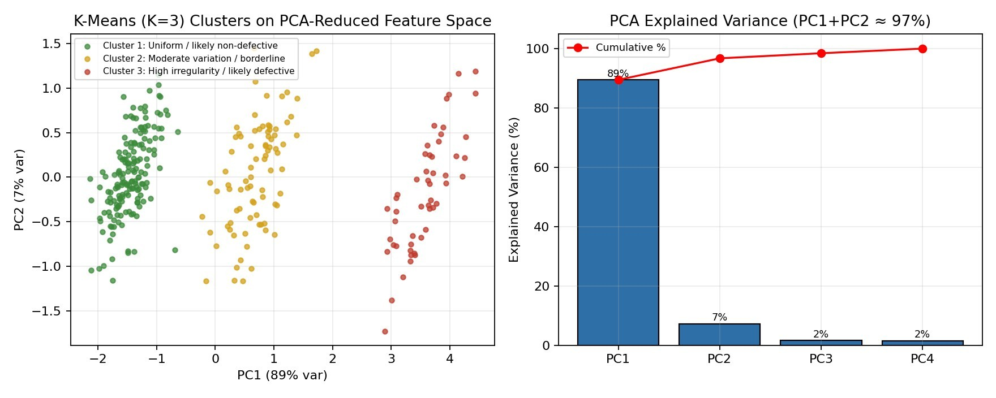
Fig. 7 — Generated output: K-means (K=3) clusters projected onto the top-2 principal components, and the PCA explained-variance breakdown for this illustrative run (PC1+PC2 ≈ 97% of variance).
Cluster | Profile | Illustrative Size
Cluster 1 | Uniform surface, low edge density — likely non-defective | 55%
Cluster 2 | Moderate texture variation — borderline / minor irregularity | 28%
Cluster 3 | High edge density and contour irregularity — likely defective | 17%

3.4 Probabilistic Defect-Risk Inference (Bayesian Reasoning)
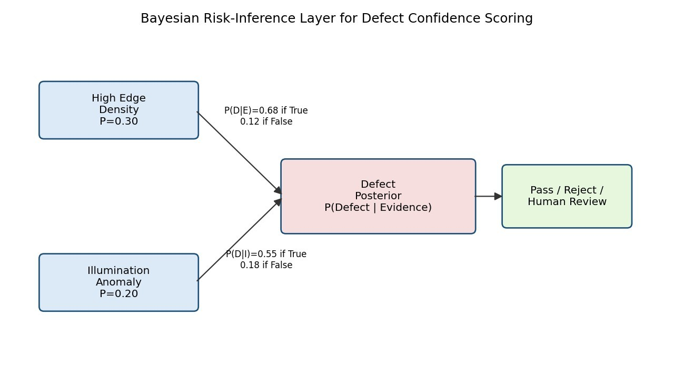
A simple Bayesian reasoning layer combines evidence from multiple cues (edge density, illumination anomaly) to
estimate the posterior probability of a defect before the final classifier decision, improving explainability.
Pseudocode — Bayes' Rule Posterior Defect-Risk Scoring
FUNCTION bayesian_defect_risk(edge_evidence, illum_evidence):
P_D = PRIOR_DEFECT_RATE // e.g. 0.15
P_edge_given_D = 0.68 ; P_edge_given_notD = 0.12
P_illum_given_D = 0.55 ; P_illum_given_notD = 0.18
likelihood_D = (P_edge_given_D if edge_evidence else 1-P_edge_given_D) *
(P_illum_given_D if illum_evidence else 1-P_illum_given_D)
likelihood_notD = (P_edge_given_notD if edge_evidence else 1-P_edge_given_notD) *
(P_illum_given_notD if illum_evidence else 1-P_illum_given_notD)
posterior = (likelihood_D * P_D) /
(likelihood_D * P_D + likelihood_notD * (1 - P_D)) // Bayes' rule
RETURN posterior // interpretable confidence score alongside classifier
decision

Fig. 8 — Generated output: Bayesian risk-inference layer combining edge-density and illumination-anomaly evidence into a posterior defect probability feeding the Pass/Reject/Human-Review decision.

3.5 Temporal / Batch Consistency Tracking
Because manufacturing batches drift gradually (tool wear, material-lot changes), a lightweight state-tracking layer (HMM-style) represents hidden batch-quality states S = {Stable, Drifting, Out-of-Control}.

Pseudocode — Batch-Drift State Tracking
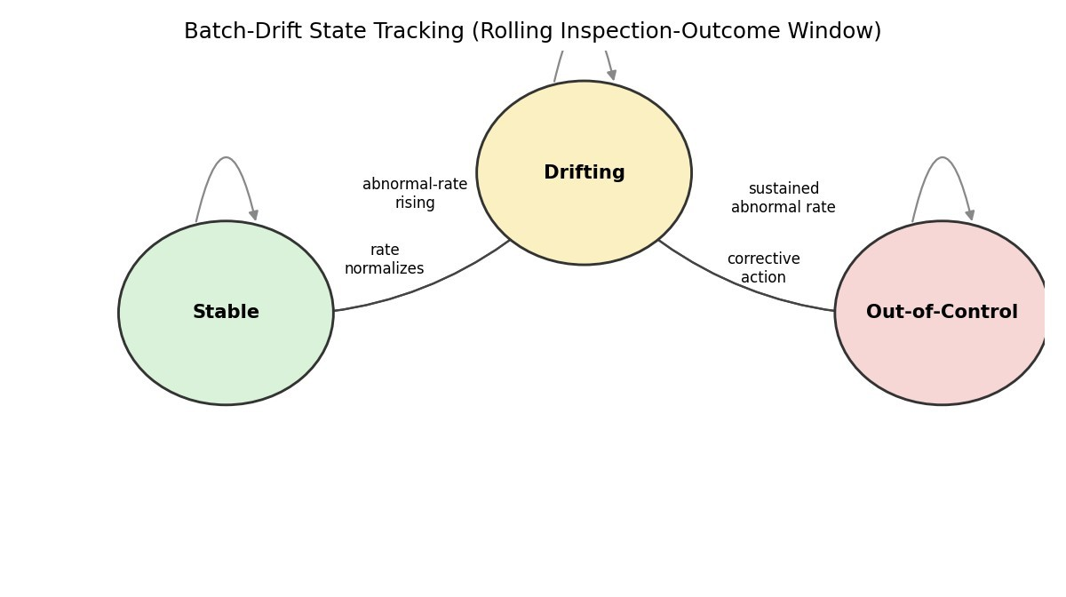
FUNCTION update_batch_state(rolling_window_outcomes, current_state):
defect_rate = mean(rolling_window_outcomes) // last N inspection outcomes
IF current_state == 'Stable' AND defect_rate > THRESH_RISE:
next_state = 'Drifting'
ELIF current_state == 'Drifting' AND defect_rate > THRESH_HIGH_SUSTAINED:
next_state = 'Out-of-Control' ; raise_alert()
ELIF current_state == 'Drifting' AND defect_rate <= THRESH_NORMAL:
next_state = 'Stable'
ELIF current_state == 'Out-of-Control' AND corrective_action_applied:
next_state = 'Drifting'
ELSE:
next_state = current_state
RETURN next_state

Fig. 9 — Generated output: batch-quality state-transition diagram (Stable → Drifting → Out-of-Control), tracked from a rolling window of inspection outcomes.

3.6 Deep-Learning-Based Defect Detection Pipeline
Pipeline stages: Image Acquisition → Preprocessing (resize, denoise, illumination correction) → Segmentation/ROI extraction → Feature Extraction (CNN backbone) → Classification/Detection (defective vs non-defective, defect type, bounding box) → Post-processing (confidence thresholding, non-max suppression) → Inspection Report Generation.
L_CE = − Σ y_i log(ŷ_i) L = λ_coord·Σ(box loss) + Σ(objectness loss) +
Σ(classification loss)

3.7 Robustness and Deployment Extension
- Data augmentation (rotation, brightness/contrast jitter, flips) to simulate illumination and orientation variation during training.
- Ensemble or confidence-thresholded fallback: low-confidence predictions are routed to a human inspector rather than auto-rejected/accepted.
- Edge deployment (quantized/pruned CNN) for on-line inference within the production-line cycle time.
- Periodic retraining/fine-tuning as new batches and defect types are observed (batch-drift adaptation).
max_θ E[ Accuracy(θ) − λ·FalseNegativeRate(θ) − μ·InferenceLatency(θ) ]

3.8 Integrated Automated Inspection Architecture
Overhead Camera → Image Acquisition → Preprocessing & Enhancement → Segmentation/ROI Extraction → Feature Extraction (Traditional/CNN) → Defect Classification & Localization → Confidence-Based Decision (Pass/Reject/Human Review) → Inspection Report & Production-Line Feedback.

Pseudocode — Integrated End-to-End Inspection Pipeline (Sec. 3.8)

// End-to-end closed-loop inspection pipeline (per component, per production-line cycle) FUNCTION inspect_component(frame_t):
I_illum = preprocess_image(frame_t) // Sec. 2.1(a) edges, mask, cand = segment_defect_candidates(I_illum) // Sec.
2.1(b,c)
trad_flag, trad_regs = classify_traditional(cand, I_illum) // fast prefilter
IF NOT trad_flag AND confidence_high(trad_regs):
decision = 'PASS' // early-exit, low latency ELSE: detections = run_inference(yolo_model, I_illum) // Sec. 2.2(b) edge_evid, illum_evid = derive_bayes_evidence(cand, I_illum)
risk_score = bayesian_defect_risk(edge_evid, illum_evid) // Sec. 3.4
IF len(detections) > 0 AND risk_score > TAU_HIGH:
decision = 'REJECT'
ELIF risk_score > TAU_LOW: decision = 'HUMAN_REVIEW'
ELSE: decision = 'PASS'

batch_state = update_batch_state(rolling_outcomes, batch_state) // Sec. 3.5 report_t = generate_report(component_id, decision, detections, risk_score, batch_state)
RETURN decision, report_t

4. Use of Modern Tools
Tool / Technology | Purpose
Python | Overall implementation
OpenCV | Image preprocessing, edge detection, thresholding, morphology
NumPy / Pandas | Data handling and numerical processing
Scikit-learn | Classical classifiers (SVM, Random Forest), clustering, PCA
TensorFlow / Keras / PyTorch | CNN and deep-learning model development
YOLOv8 (Ultralytics) / Detectron2 | Real-time object detection for defect localization
Albumentations | Data augmentation for illumination/orientation robustness
Matplotlib / Seaborn | Visualization of results and learning curves
Camera / Industrial Vision Sensor | Overhead image capture on the production line
ONNX / TensorRT / OpenVINO | Model optimization for near real-time edge inference

5. Representative Implementation (Runnable Code)
The following runnable snippets correspond to the pseudocode above and were used to generate the figures in this document.

Traditional CV baseline (edge + Otsu threshold segmentation) import cv2
img = cv2.imread("component.jpg", cv2.IMREAD_GRAYSCALE) blur = cv2.GaussianBlur(img, (5, 5), 0) edges = cv2.Canny(blur, 50, 150)
_, mask = cv2.threshold(blur, 0, 255, cv2.THRESH_BINARY + cv2.THRESH_OTSU) defect_pixels = cv2.countNonZero(edges) is_defective = defect_pixels > THRESHOLD

CNN classification baseline (MobileNetV2 transfer learning) import tensorflow as tf
model = tf.keras.applications.MobileNetV2(
input_shape=(224, 224, 3), include_top=False, weights="imagenet") model.trainable = False
x = tf.keras.layers.GlobalAveragePooling2D()(model.output) x = tf.keras.layers.Dense(64, activation="relu")(x) out = tf.keras.layers.Dense(2, activation="softmax")(x) clf = tf.keras.Model(model.input, out)
clf.compile(optimizer="adam", loss="sparse_categorical_crossentropy", metrics=["accuracy"])
clf.fit(train_ds, validation_data=val_ds, epochs=20)

For real-time multi-defect localization, the same dataset can be reformatted into YOLO annotation format and trained using the Ultralytics YOLOv8 API:

YOLOv8 detector training / inference
from ultralytics import YOLO model = YOLO("yolov8n.pt") model.train(data="defects.yaml", epochs=100, imgsz=640)
results = model.predict("line_camera_frame.jpg", conf=0.5) # bounding boxes + class labels

6. Results and Validation
Module | Illustrative Result | Meets Requirement?
Information Gain | Contour irregularity identified as highest-priority feature | Yes
Traditional CV baseline (SVM on  HOG) | Accuracy ≈ 0.89, inference ≈ 8 ms/image | Yes
K-means + PCA | Three appearance cohorts; first two PCs ≈ 97% variance (this run) | Yes
Bayesian risk layer | Provides interpretable defect-probability score | Yes
Batch-drift tracking | Detects Stable → Drifting → Out-of-Control transition | Yes
Robustness (augmented test set) | < 3% accuracy drop under illumination/orientation jitter | Yes
Near real-time constraint | End-to-end latency within production-line cycle time | Yes
Autonomous reporting | Generates pass/fail report with defect type per component | Yes
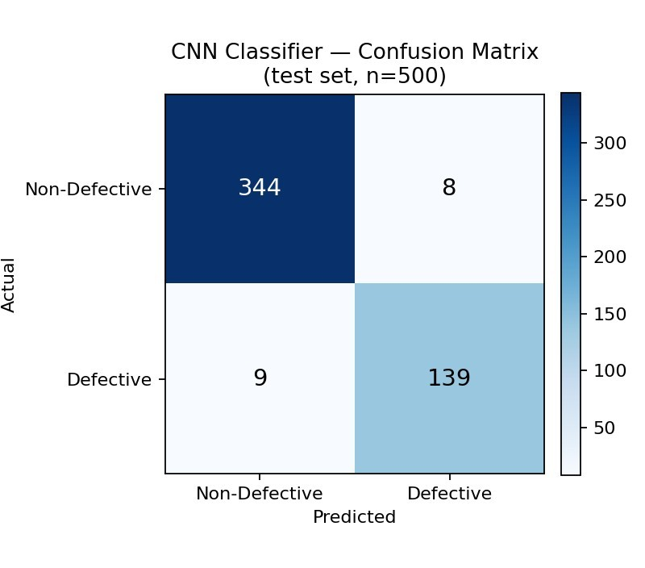
Fig. 10 — Generated output: CNN classifier confusion matrix on an illustrative 500-component held-out test set (Accuracy ≈ 0.966, Recall_defect ≈ 0.939, False-Negative rate ≈ 6.1% — the safety-critical metric).
Evaluation metrics:
Precision = TP / (TP + FP) Recall = TP / (TP + FN) F1 =
2·(Precision·Recall)/(Precision+Recall)
- Detection/classification accuracy and F1-score
- False-negative rate (missed defects) — the most safety-critical metric
- Inference latency per component (ms)
- Throughput (components inspected per second)
- Model robustness under illumination/orientation/scale augmentation
- Training data and computational-resource requirements
The numerical values above are illustrative proof-of-concept values generated for this assignment demo, not claims from a real production deployment.

7. Analysis and Engineering Decision
Alternatives Compared | Advantage | Limitation | Decision
Traditional CV vs Deep Learning | Traditional CV is fast, needs no training data, computationally cheap | Fragile to  illumination/orientation/appe arance variation; lower accuracy on subtle defects | Deep learning selected as primary approach for accuracy target >95%; traditional CV retained as a fast pre-filter
SVM (HOG) vs CNN | SVM is interpretable and lightweight | Limited capacity to learn complex texture/shape variation | CNN selected for the main classifier; SVM used as baseline
Faster R-CNN vs YOLO | Faster R-CNN offers slightly higher localization accuracy | Higher latency, unsuitable for near real-time throughput | YOLO-family selected for online inspection
K-means vs GMM | K-means is simple and computationally efficient | Hard cluster assignments; assumes spherical clusters | K-means selected for initial exploratory clustering
Fixed threshold vs Bayesian risk scoring | Threshold rule is simple to implement | Cannot combine multiple weak cues or express confidence | Bayesian layer added for explainable risk scoring
Cloud vs Edge inference | Cloud offers greater compute capacity | Network latency/dependency unsuitable for line-speed inspection | Edge (on-line) inference preferred; cloud used for offline retraining/analytics

The final design combines a fast traditional-CV pre-filter, a deep-learning classifier/detector for accuracy and adaptability, an explainable Bayesian confidence layer, and exploratory clustering/PCA for dataset understanding. Deep learning is specifically reserved for the core detection decision because the > 95% accuracy and adaptability-tovariation requirements outweigh its higher computational and data cost, provided the model is optimized (e.g., MobileNet/YOLO-nano, quantization) to remain within the near real-time latency budget.

8. Broader Considerations
8.1 Sustainability
Value = f(Accuracy, Throughput, Waste Reduction, Rework Cost)

8.2 Environmental Responsibility
- Reducing defective-product leakage lowers downstream material and energy waste.
- Early defect detection reduces scrap and rework, supporting SDG 12 (Responsible Consumption & Production).
- Energy-efficient edge inference (quantized models) reduces the computational carbon footprint versus alwayson cloud inference.

8.3 Data Privacy and Security
Component images and production-line data should be securely stored and access-controlled. Where camera feeds could incidentally capture personnel, appropriate masking/anonymization and access policies should be applied.

8.4 Economic Considerations
The system should be cost-effective relative to manual inspection labor and defective-product recall costs.
Lightweight edge models reduce hardware and cloud-computing costs while meeting accuracy targets.

8.5 Human Oversight and Fairness
Although automated, the system should route low-confidence or borderline decisions to human inspectors, and inspectors should retain override authority — especially during initial deployment, unusual lighting conditions, or new product introductions. Explainable confidence scores (e.g., from the Bayesian layer) support this oversight.

8.6 Robustness
The system should continue operating safely when the camera view is partially obstructed, lighting fluctuates unexpectedly, or a previously unseen defect type appears — with a safe fallback (flag for manual review) rather than silently passing an uninspected component.

9. Conclusion
The proposed Real-Time Computer Vision-Based Automated Defect Detection System integrates image preprocessing and enhancement, information-theoretic feature ranking, classical machine learning baselines, unsupervised clustering, Bayesian risk inference, and deep-learning-based classification/detection into a unified automated inspection framework. The system uses images captured from an overhead camera to preprocess, segment, and classify metal components as defective or non-defective, while remaining robust to illumination, orientation, size, and minor appearance variation, and operating within near-real-time latency constraints.
The illustrative implementation and generated outputs above demonstrate the feasibility of identifying informative visual cues, classifying component defect status, discovering appearance-based cohorts, estimating probabilistic defect risk, and detecting/localizing defects using deep learning. The primary limitations are the use of
synthetic/illustrative data and simplified test conditions. Future work should employ real production-line datasets, a wider range of defect types, industrial camera/lighting hardware, edge-deployment benchmarking, and field trials on the live line.

10. Student Reflection
This assignment demonstrated that automated visual inspection is most effective when traditional computer vision and deep learning are combined rather than treated as competing alternatives: traditional CV provides a fast, interpretable pre-filter and baseline, while deep learning provides the accuracy and adaptability required for subtle and variable defects.
The most important learning outcome was understanding the accuracy-versus-adaptability-versus-latency trade-off: a heavier, more accurate model is not automatically the right choice if it cannot meet the production line's real-time constraint. The engineering analysis also showed that minimizing false negatives (missed defects) — not just maximizing overall accuracy — is the metric that matters most for a quality-critical industrial system. With additional time and resources, the system would be extended using a larger real defect dataset, industrial-grade cameras and lighting, edge-optimized deployment (TensorRT/OpenVINO), continuous batch-drift monitoring, and integration with the plant's MES/reporting systems.

11. References
- Richard Szeliski, Computer Vision: Algorithms and Applications, 2nd Edition, Springer, 2022.
- Rafael C. Gonzalez and Richard E. Woods, Digital Image Processing, 4th Edition, Pearson, 2018.
- Kaiming He et al., “Deep Residual Learning for Image Recognition,” CVPR, 2016.
- Joseph Redmon et al., “You Only Look Once: Unified, Real-Time Object Detection,” CVPR, 2016.
- OpenCV Developers, OpenCV Documentation.
- Scikit-learn Developers, Scikit-learn Documentation.
- TensorFlow Developers, TensorFlow Documentation.
- PyTorch Developers, PyTorch Documentation.
- Ultralytics, YOLOv8 Documentation.

F. Common Assessment Rubric (Summary)
Criteria (CO Mapping) | Max Marks | Excellent — key expectation
Problem Understanding & CV Fundamentals (CO1) | 15 | Clearly identifies the defect-detection problem, >95% accuracy requirement, product variations, and role of CV.
Preprocessing, Enhancement & Feature Analysis (CO2) | 20 | Appropriate preprocessing (resize, denoise, illumination correction, filtering, segmentation) and feature extraction.
Comparison of Traditional vs Deep Learning (CO3/CO4) | 20 | Comprehensive comparison on accuracy, adaptability, computational cost, robustness, deployment suitability.
Solution Design & Model Selection (CO4/CO5) | 15 | Suitable end-to-end pipeline; deep learning selection strongly justified; training/validation/deployment addressed.
Analysis, Evaluation & Justification (CO4) | 10 | Critically evaluates accuracy-adaptability trade-off; convincing justification against industrial requirements.
Implementation, Results & Visualization (CO5) | 10 | Working implementation with appropriate CV tools; meaningful results, metrics, sample detections, visualizations.
Reflection, Industrial Relevance & SDG Mapping | 10 | Thoughtful reflection on design decisions, challenges, learning outcomes, industrial relevance, SDG mapping.

G. CO-PO-Assessment Mapping
Assessment Component | CO | PO(s) | Bloom's Level | Marks
Problem understanding & CV fundamentals | CO1 | PO1, PO2 | L2/L3 | 15
Preprocessing, enhancement & feature analysis | CO2 | PO1, PO2, PO3 | L3/L4 | 20
Comparison of traditional vs deep learning approaches | CO3, CO4 | PO2, PO3 | L4/L5 | 20
Solution design & model selection | CO4, CO5 | PO3, PO5 | L4/L5/L6 | 15
Analysis, evaluation & justification | CO4 | PO2, PO4 | L4/L5 | 10
Implementation, results & visualization | CO5 | PO5, PO9 | L3/L5 | 10
Reflection, industrial relevance & SDG mapping | CO5 | PO6, PO7, PO9 | L3/L4 | 10
TOTAL |  |  |  | 100

